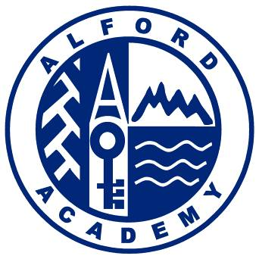

Alford Community Campus
Greystone Road
Alford AB33 8TY
Telephone 019755 20430
alford.aca@aberdeenshire.gov.uk
www.alfordacademy.aberdeenshire.sch.uk

Thursday 24th August 2022
Financial Support Opportunities and Information
Dear Parent / Carer,
I would like to take this opportunity to share with you some information on financial supports that you may find helpful, particulary in the current climate where we are experiencing rising costs for food, fuel and energy payments. I hope you find this useful and please do not hesitate to get in touch if I can help you in any way.
Cost of Living Support
Aberdeenshire council have a page on their website dedicated to providing support / links for energy bills, council tax, food banks and more. Access their page : https://www.aberdeenshire.gov.uk/communities-and-events/cost-of-living/

Free School Meals and Clothing Grant
Children are eligible for free school meals if their parents (or carers) are in receipt of a qualifying benefit:
- Income Support (IS)
- Income Based Job Seekers Allowance (JSA)
- Pension Credit (Guarantee Credit)
- Any income related element of Employment Support Allowance
- Child Tax Credit (CTC), but not Working Tax Credit (WTC), and have an income of less than £17,005
- Both Child Tax Credit and Working Tax Credit with an income of less than £7,920
- Support under Part VI of the Immigration and Asylum Act 1999
- Universal Credit with a monthly net pay from your employer of less than £660 (this is based on your actual net pay, not the figure determined by Universal Credit)
Futher information and the application form can be accessed : https://www.aberdeenshire.gov.uk/schools/school-info/assistance/free-school-meals/

Education Maintenance Allowance
The Education Maintenance Allowance (EMA) is an allowance of £30 per week, which can be paid to eligible students who stay on in education after the age of 16 years. Your EMA is paid every 2 weeks during school term time and it is not paid during the holidays. You can apply using this link but please contact me directly if you need any help making the application.
https://aberdeenshire.gov.uk/schools/school-info/assistance/ema/

Worrying About Money? – Financial Advice and Support Leaflet.
Please find attached a support leaflet that provides information on where you can access support within Aberdeenshire.
Cash For Kids Emergency Fund
This is a fund that I can apply for on your behalf, there is no limit to the number of applications I can make for you and it can be used to cover costs for essential items e.g. heating, food, clothes, phone and electricity top ups etc.
Each application, if accepted, will receive a minimum of £100 depending on your circumstances and is usually provided within 7 days. In order to qualify for this funding you must be experiencing / affected by poverty and your children must be between 0-18 years old and live in Aberdeen or Aberdeenshire. I would a require a brief explanation of what you would use this payment for and you will need to provide me with evidence / receipts of your spending.

Bed Poverty
Cash for kids can provide beds for children who currently don’t have their own bed to sleep in at night. If you wish to apply for this then please contact me directly and I will make the application on your behalf. The application, if successful, will be fulfilled with a single bed, mattress, duvet and pillow which will arrive ‘flat packed’ and will require assembly by you. No other type or style of bed can be supplied.

Free Bus Travel : Young Scot Card - We can process this on your behalf. Please contact the school office directly for the relevant forms or access the links below.
Pupils Under 16 :
Step-by-step instructions on how parents/carers can request a replacement National Entitlement Card (NEC) or Young Scot NEC with free bus travel for their child using getyournec.scot. This shows the process for requesting a replacement card for a child aged 5-15 who already has a Young Scot card or other National Entitlement Card. : https://www.youtube.com/watch?v=Qww1k54WM8M

Applications for Pupils Over 16 :
Use the following link and download the ‘Transport Scotland’s Pass Collect App’ - https://www.transport.gov.scot/concessionary-travel/young-persons-free-bus-travel-scheme/#70015
There is a short video to explain the stages of how to apply.

Period Products : I can provide these for you if required or you can access products via Aberdeenshire council on : https://www.aberdeenshire.gov.uk/communities-and-events/sanitary-products/

School Uniform
I am aware that the purchase of school uniform can place a burden on families. Please find attached a list of items that I currently have available and can provide to you on a first come, first served basis. However, I am aware that this may not meet current demand and the emergency fund can be used to apply for funding to purchase new uniform items if required. Please make contact with me directly if you are in need of uniform items.

Further Supports
Aberdeenshire North Food Bank : https://aberdeenshirenorth.foodbank.org.uk/

Gordon Rural Action : https://gordonruralaction.org.uk/

Information on financial assistance and Wellbeing support can be found on our ‘Parent and Carers Support Site’ : https://sites.google.com/as.glow.scot/alfordacademyparentcarer/home but please get in touch if you feel I can offer any further assistance.

Kind regards

Mrs J Munro
PT Equity, Excellence and Wellbeing
Alford Academy

jo.munro@aberdeenshire.gov.uk

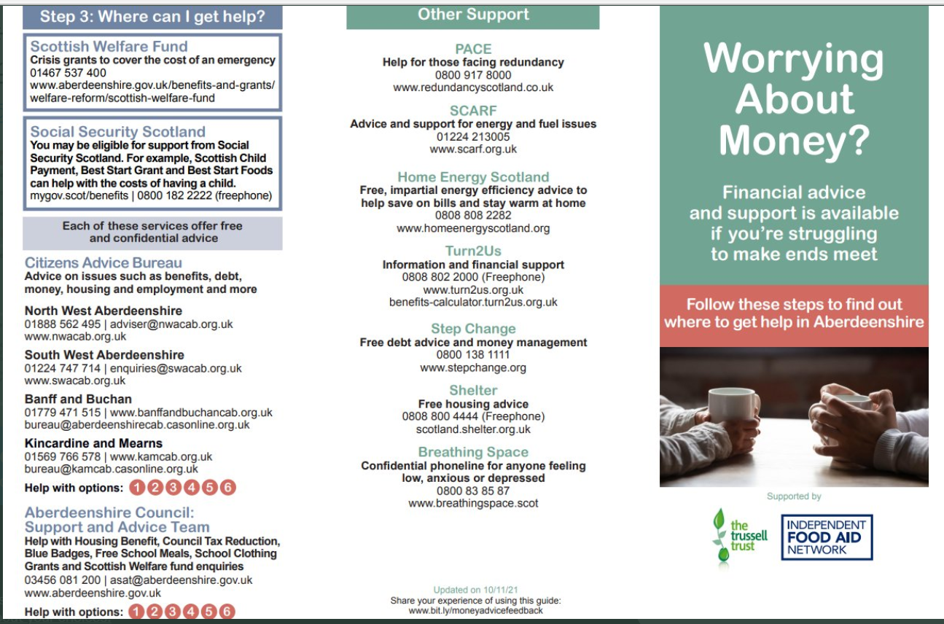
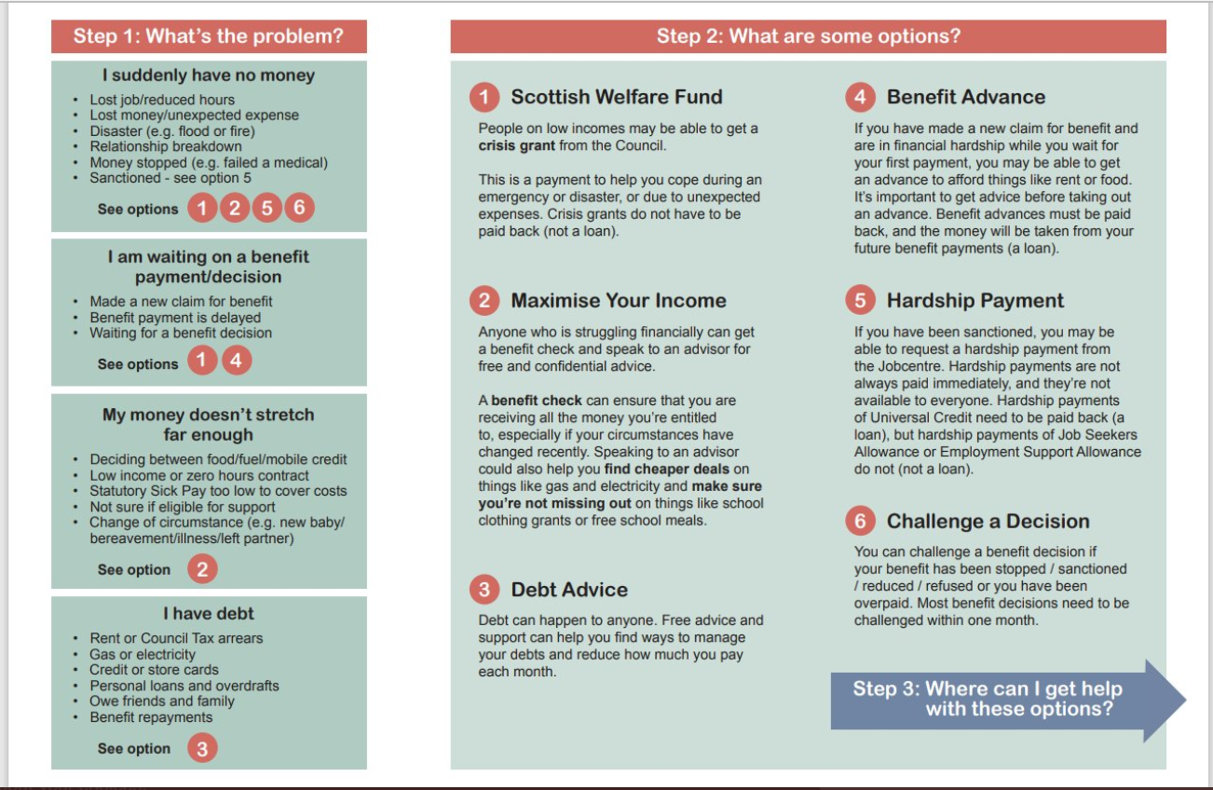
Preloved Uniform : Alford Academy - August 2022
 | Size | Quantity
Boys School Jumper
 | Medium  (86-92cm / 34-36”) | 2
 | X-Large | 1
Boys School Trousers
 | Age 10-11  (Height 140-146cm) | 1
 | Age 11-12  (Height = 146 – 152 cm/60”)  (Waist = 68cm / 26 ¾ “) | 5
 | Age 11-12  (Waist = 68cm / 26 ¾ inch)  (Length = 152cm / 60 inch) | 4
 | Age 12 Slim Fit  (Length 152cm) | 2
 | Waist 28” / 71cm  Inside Leg = 31” / 79cm | 3
Unisex Shorts
 | Age 12-13  (Height = 158cm / 62”)  (Waist = 70 ½ cm / 28”) | 1
Girls School Trousers
 | 30 Waist / 30 short  Skinny Fit | 1
Girls School Skirt
 | Age 14-15 | 2
Girls School Jumper
 | Age 11-12  (71-76cm / 28-30 inch) | 1
 | Age 13  (78-81cm / 31-32 inch) | 3
 | Small  (81-86cm / 32-34 Insch) | 3
Girls School Cardigan
 | Small  (81-86cm / 32-34”) | 1
Unisex School Jumpers
 | Small | 5
Short Sleeved School Shirt (White) Unisex
 | Age 10-11  (Height = 140-146cm) | 1
 | Age 11-12 (Slim Fit)  (Collar = 34cm / 13 ½ Inch)  (Chest = 78cm / 30 ½ Inch) | 3
 | Age 12 Slim Fit  (Height = 152cm) | 2
 | Age 12  (Height 152cm) | 1
 | Age 14  (Height 164cm) | 2
Long Sleeved (White) Shirt Unisex
 | Age 13-14 | 3
 | Age 14-15 | 3
 | Age 15-16  (Chest 94cm / 37”) | 1
 | Age 16 | 5
Boys Blazer
 | 36” | 1
Girls Blazer
 | 30” | 3
 | 32” | 6
 | 42” | 1
School Ties
 | One Size | 7

