Lost Property : Winter Jackets – November 2022

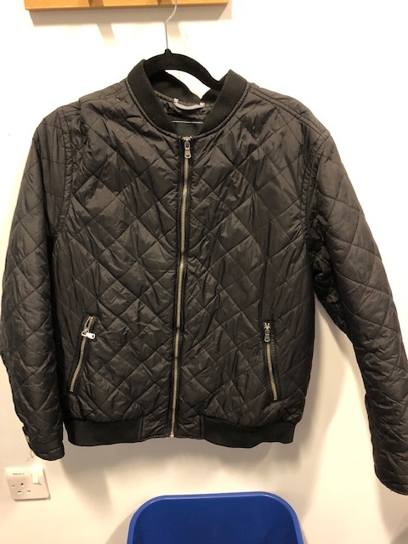

Red Herring Size Large Adult

Jack and Jones Size Small Adult

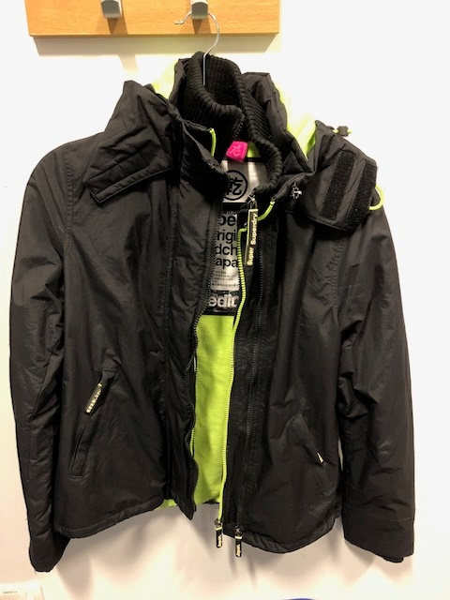

Gerry Age 13

Superdry Size Medium Adult

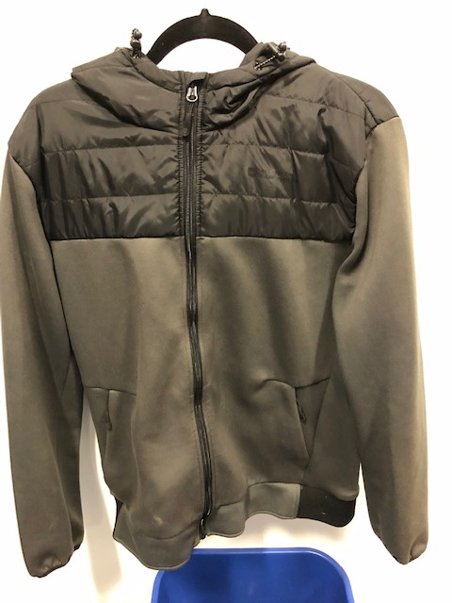

Mountain Warehouse Size Large Adult

Superdry Ladies Size 10

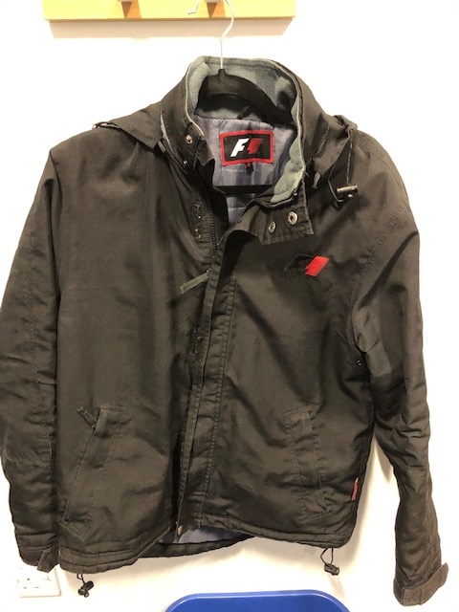

Eight Eight Three Size 3

Formula One Size Small Adult

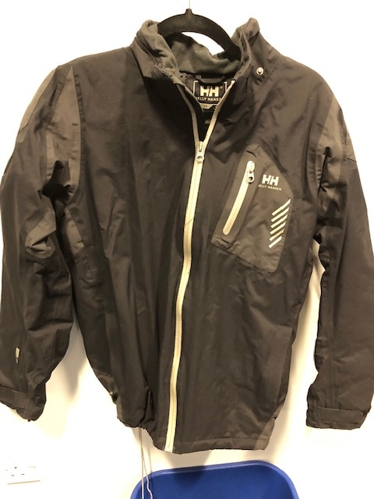 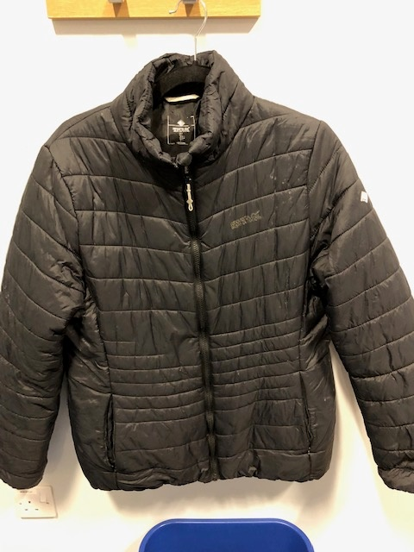

Regatta Age 16

Helly Hansen Age 16

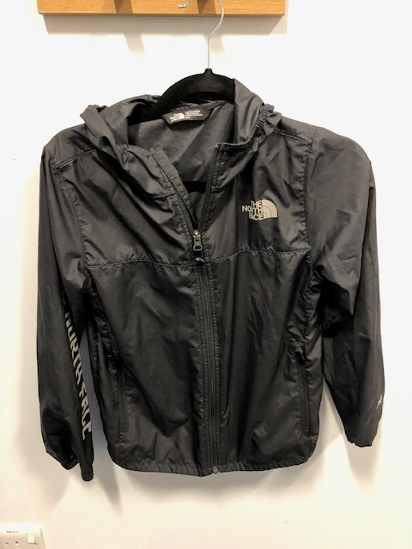 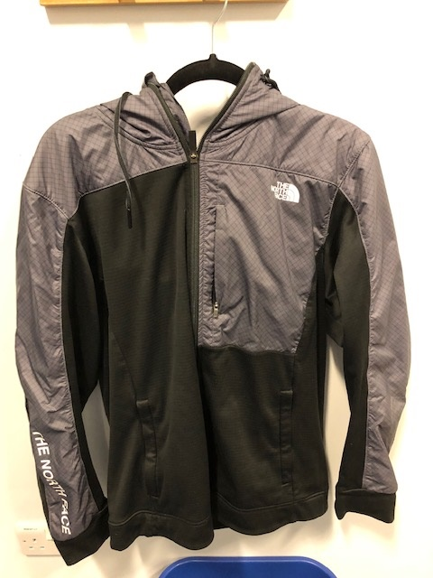

Northface Size Large Adult

Northface Size Medium Youth

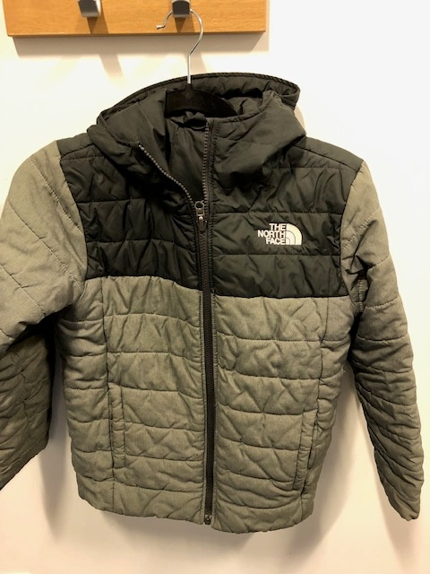 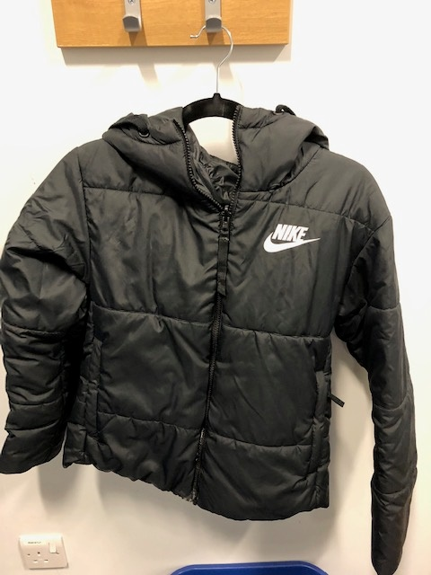

Nile Size Small Adult

Northface Size Medium Youth